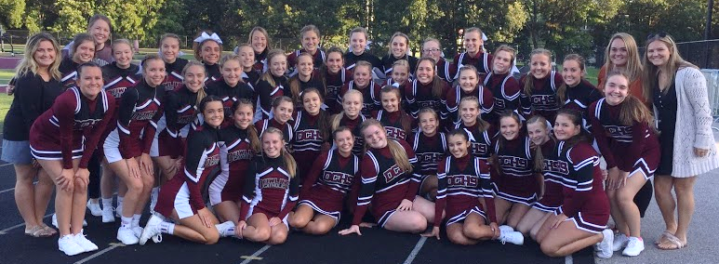

Dowling Catholic Cheerleading 2020-2021
What: Save the dates! Join us for Dowling Catholic Cheerleading Open Gyms, Information Nights and Try Outs for 2020-2021 school year

When & Where:
- Open Gyms
2/9 3:30-5pm Cafeteria
2/16 5-6:30pm Cafeteria
3/1 & 3/8 3:30-5pm DCHS Small Gym
- Parent & Cheerleader Information Meeting
3/8 5:30pm DCHS Library
- Try Out Practices
3/23 – 3/26 6-8:30pm DCHS Small Gym
- Try Outs
3/27 6-10pm DCHS Small Gym
- Results Posted
3/28 by noon
- MANDATORY Parent & Cheerleader Meeting and Uniform Fitting
4/7/20 5:30pm-7pm DCHS Library

Details:
Open Gyms: DCHS Cheer Coaches look forward to working with you and seeing you share your talents! Join us for open gyms in preparation for try outs, get to know our warm up routine and conditioning drills as well as practice your stunting and tumbling.
Information Meeting: Come learn how squads will be designed for 2020-2021 school year as well as what to expect prior to trying out including uniform updates, mandatory dates, etc. Come hear from our Coaches about all that we have in store for this big year!
Try Out Practices and Try Outs: We can’t wait to see you shine! Be sure to attend all the practices prior to try outs in order to learn the cheers, practice your jumps, and be prepared.
Results: Squads will be posted on our cheerleading website at: https://sites.google.com/dowlingcatholic.org/dchscheerleading/rosters
MANDATORY Parent & Cheerleader Meeting & Uniform Fitting: We will review the year in further detail, please come prepared with your deposit and place your uniform order.

Contact Cheer Coach Kendra Marshall (dchscheercoaches@gmail.com) with any questions

